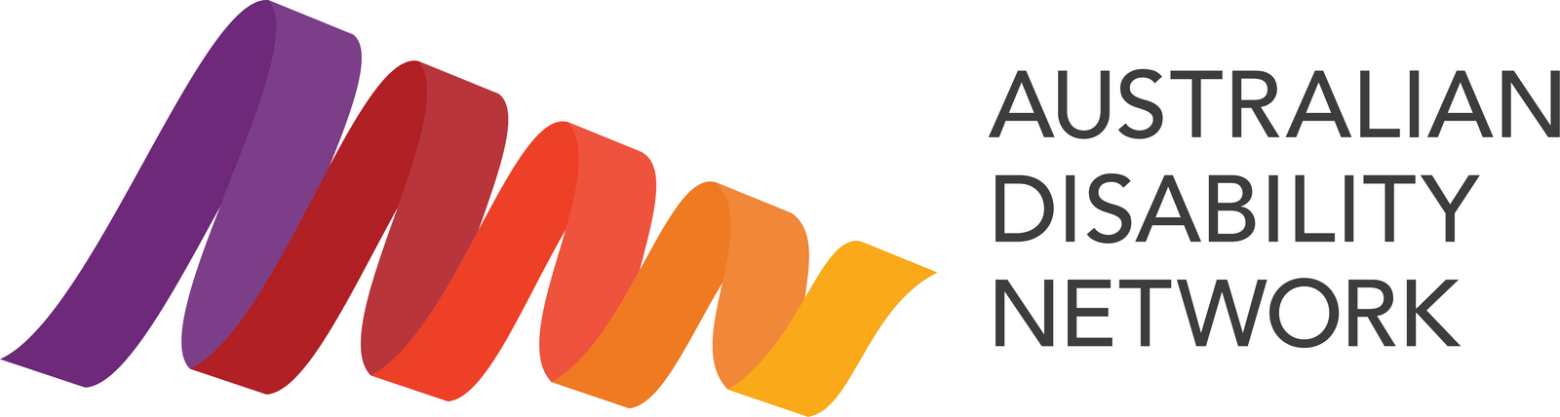

Disability Confidence Awards 2026: Partnership Prospectus
Tuesday 20 October 2026. The Sofitel, Melbourne.
An evening for 350 guests and 15 award categories, drawn from our network of more than 440 member organisations.

Why be part of it
More than one in five Australians lives with disability.
The Disability Confidence Awards recognise the organisations and people making disability inclusion real across Australia.
When you're part of the Awards, you:
- Put your name against real change. Finalists and winners show what good practice looks like in hiring, accessible design, customer experience and employee networks.
- Help set the benchmark. Every finalist becomes a practical example other employers can learn from and build on.
- Reach beyond the night. Stories run from October through to International Day of People with Disability on 3 December.
- Get a seat in the room. 350 senior leaders, people and culture teams, accessibility practitioners and people with lived experience.

Three ways to say yes
Whatever suits your organisation this year, there's a way to be part of it.
- Come along and bring your people. Book a seat or a table and turn it into a night out that means something. Book your place now.
- Gift a seat. Buy a seat for someone who'd love to attend but may not be able to afford it, and we'll pass it on to a guest from our community. Gift a seat now.
- Partner with us. From $2,500 up to $15,000 for a lead Platinum partnership, with options for every size of organisation. Reach out to learn more.
A note on timing and travel: the Awards sit in the lead-up to International Day of People with Disability on 3 December, so being part of them, whether as a partner, guest, finalist or winner, gives you a ready-made story for your own activity. As the Awards are in Melbourne this year, if you'd be travelling, it's worth planning ahead.

Ways to partner
We've opened more ways to be part of the night this year, from as little as $2,500 up to $15,000 for a lead Platinum partnership, so there's an option for organisations of every size.
Package | Investment (excl. GST) | What's included
Platinum Partner | $15,000 | Lead billing, speaking slot, a full table of 10, your own webinar, present an award
Gold Partner | $10,000 | Strong visibility, present an award, half-page feature, 4 seats
Accessible 360 Photo Booth Partner | $8,000 | Name and brand the most-shared moment of the night; your logo on every guest's photo and video; 2 seats
Quiet Room Partner | $8,000 | Name and brand the calm, low-sensory space; recognition for practical inclusion on the night; 2 seats
Silver Partner | $6,000 | Recognition, present an award, logo on screens, 2 seats
Bronze Partner | $4,000 | Logo in program, social recognition, website listing, 2 seats
Supporter | $2,500 | Name listed in the program, website listing, 1 seat
Accessibility Services Partner | In-kind | Booked for 2026. Thank you to our accessibility services partner for providing Auslan interpreting and live captioning on the night.
All prices exclude GST. Full benefit detail for each package is available on request, and will be included in the complete prospectus.

Other ways to attend and support

Attend, or gift a seat
Prefer to bring your team or clients, or help someone else attend? These options are priced at cost and do not include branding, stage or social media benefits.
Option | Investment (excl. GST)
Table of 10 (members) | $2,750
Table of 10 (non-members) | $3,500
Individual seat (members) | $275
Individual seat (non-members) | $350
Gift a seat (member rate, per seat) | $275
Gift a seat: buy a seat for someone who'd love to attend but may not be able to afford it, and we'll pass it on to a guest from our community. It's the same price as a member seat, and there's no limit on how many you can gift. Choose "Gift a seat (member rate)" in Humanitix. If you're booking for yourself or your own team, please choose a standard member or non-member seat instead.
Seats are booked through Humanitix. Prices exclude GST, and Humanitix adds its own booking fees at checkout, which are set by Humanitix rather than Australian Disability Network.

Program advertising
Place your message in the printed awards program, seen by every guest on the night.
Advertising size | Price (excl. GST)
Full page | $2,000
Half page | $1,200
Quarter page | $700

Get in touch
We'd love to have you with us. We're happy to tailor something to suit your organisation, or to combine a partnership across the Awards and IMPACT 2027 for even greater reach. Partnerships are allocated first-come, first-served, so please get in touch early.
Katie Wilson, Head of Marketing and Communications
Email: katie.wilson@ausdn.org.au
Phone: (02) 8270 9224
Web: www.australiandisabilitynetwork.org.au
All prices are exclusive of GST unless otherwise stated. Partnership benefits are subject to availability and allocated on a first-come, first-served basis.
Australian Disability Network, ABN 92 456 457 335.

