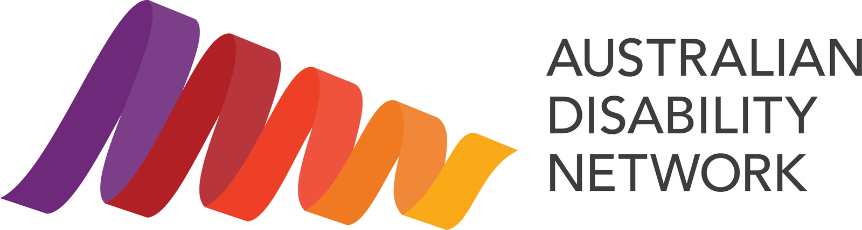

Disability Confidence Awards 2026: Partnership Prospectus
Tuesday 20 October 2026. The Sofitel, Melbourne.
An evening for 350 guests and 15 award categories, drawn from our network of more than 440 member organisations.

Why be part of it
More than one in five Australians lives with disability. That might be someone you work alongside, someone you serve, someone you love, or it might be you. Every year, people and organisations across the country are doing brilliant work to build workplaces and services with inclusion in mind.
The Disability Confidence Awards are the night we stop and celebrate them. On Tuesday 20 October in Melbourne, 350 leaders will come together to recognise the organisations and people driving real change on disability inclusion.
Nights like this don't happen without our members behind them. Being part of it, at any level, does two things at once: it helps shift Australia towards a more inclusive place to work and live, and it's a genuinely good night. There's a way in for every organisation, whether that's nominating someone doing great work, sponsoring a finalist to attend, or partnering with us.

Four ways to say yes
Whatever suits your organisation this year, there's a way to be part of the night.
- Nominate someone doing great work. It's free and takes minutes. Nominations are open until 14 August, across 15 categories. Nominate now.
- Come along and bring your people. Book a seat or a table and turn it into a night out that means something. Book your place now.
- Sponsor a finalist to attend. For a small amount, make sure someone who's earned their place can be there to be celebrated. Reach out to learn more.
- Partner with us. From $2,500 up to $15,000 for a lead Platinum partnership, with a genuine fit for every size. Reach out to learn more.
A note on timing and travel: the Awards sit in the lead-up to International Day of People with Disability on 3 December, so being a nominee, finalist or winner gives you a ready-made story for your own activity. As the Awards are in Melbourne this year, if you'd be travelling, it's worth planning ahead.

Who's in the room
Senior executives and C-suite, HR and people leaders, diversity, equity and inclusion teams, accessibility practitioners, and people with lived experience.

Ways to partner
We've opened more ways to be part of the night this year, from as little as $2,500 up to $15,000 for a lead Platinum partnership, so there's a genuine fit for organisations of every size.
Package | Available | Investment (excl. GST) | What's included
Platinum Partner | 2 | $15,000 | Lead billing, speaking slot, a full table of 10, your own webinar, present an award
Gold Partner | 2 | $10,000 | Strong visibility, present an award, half-page feature, 4 seats
Accessible 360 Photo Booth Partner | 1 | $8,000 | Name and brand the most-shared moment of the night; your logo on every guest's photo and video; 2 seats
Quiet Room Partner | 1 | $8,000 | Name and brand the calm, low-sensory space; recognition for genuine inclusion; 2 seats
Silver Partner | 5 | $6,000 | Recognition, present an award, logo on screens, 2 seats
Bronze Partner | Multiple | $4,000 | Logo in program, social recognition, website listing, 2 seats
Supporter | Multiple | $2,500 | Name listed in the program, website listing, 1 seat
Accessibility Services Partner | Select | In-kind | Provide Auslan interpreting or captioning in exchange for full recognition
All prices exclude GST. Full benefit detail for each package is available on request, and will be included in the complete prospectus.

Other ways to attend and support

Attend, or sponsor a finalist
Prefer to bring your team or clients, or help someone attend? These options are priced at cost and do not include branding, stage or social media benefits.
Option | Investment (excl. GST)
Table of 10 (members) | $2,750
Table of 10 (non-members) | $3,500
Individual seat (members) | $275
Individual seat (non-members) | $350
Sponsor a finalist ticket (per ticket) | $275
Attendance is booked via Humanitix, and not-for-profit booking fees apply. There is no limit on the number of finalist tickets you can sponsor.

Program advertising
Place your message in the printed awards program, seen by every guest on the night.
Advertising size | Price (excl. GST)
Full page | $2,000
Half page | $1,200
Quarter page | $700

Get in touch
We'd love to have you with us. We're happy to tailor something to suit your organisation, or to combine a partnership across the Awards and IMPACT 2027 for even greater reach. Partnerships are allocated first-come, first-served, so please get in touch early.
Katie Wilson, Head of Marketing and Communications
Email: katie.wilson@ausdn.org.au
Phone: (02) 8270 9224
Web: www.australiandisabilitynetwork.org.au
All prices are exclusive of GST unless otherwise stated. Partnership benefits are subject to availability and allocated on a first-come, first-served basis.
Australian Disability Network, ABN 92 456 457 335.

