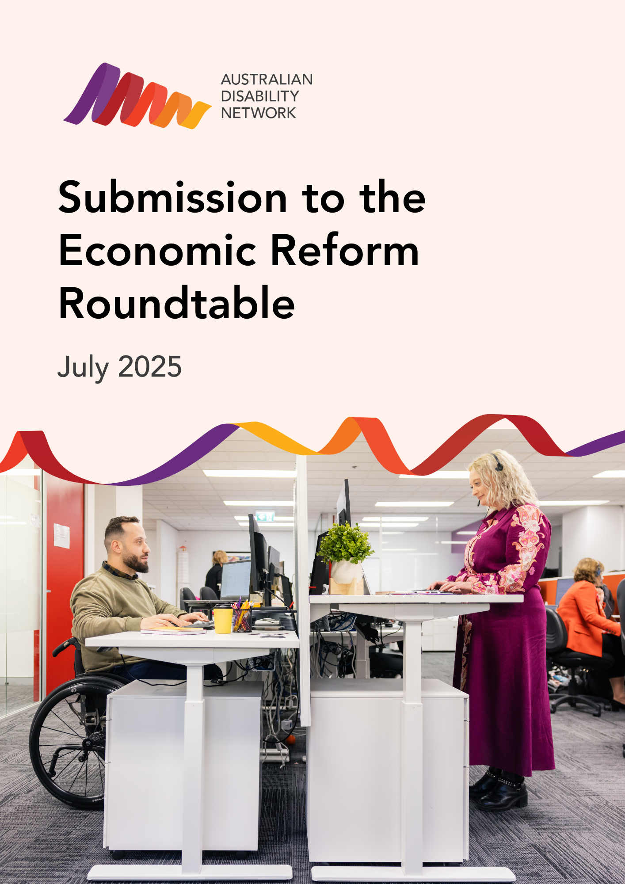

# Partnership Opportunities to Unlock Australia's Productivity Through Workplace Inclusion

## Introduction

The future of Australia’s productivity depends on how effectively we can unlock the full contribution of every available worker.

As the collective voice for more than 450 employers, including banks, retailers, government departments, transport, energy and telecommunications, Australian Disability Network knows that the systematic inclusion of people with disability is not just a social imperative, but also one of the nation’s greatest economic opportunities.

## Why Disability Inclusion drives productivity

### Workforce Utilisation

With just 53% of working-age Australians with disability currently employed, more than 500,000 potential contributors remain underutilised. Bridging even part of this gap relieves skills shortages, broadens workforce participation, and fuels economic growth.

### Skills and Capability Expansion

Inclusive hiring programs deliver measurable results, enabling employers to access high-calibre talent overlooked by traditional processes. Better trained and more inclusive managers are proven to drive stronger productivity, higher staff engagement, and improved operational outcomes right across an organisation.

### Smarter Recruitment and Retention

Skills-based, inclusive recruitment strategies achieve better job matches, lower attrition, and reduced recruitment and onboarding expenses.

### Innovation and Problem Solving

Diverse teams, including people with disability, consistently deliver higher innovation, clearer problem-framing, and robust solutions, making organisations more adaptive and competitive.

### Regional and SME Uplift

Small businesses, 68% of Australia’s private workforce, benefit the most from inclusive hiring, with positive flow-on effects for regional economies.

### Fiscally Responsible Growth

Raising the employment rate among people with disability bolsters tax revenue, reduces welfare dependency, and improves Australia’s resilience in times of economic or labour market disruption.

## Our perspective

Australian Disability Network represents **450+ employer organisations** committed to inclusive workplaces - including major banks, retail companies, transport operators, energy providers, telecommunications companies, and government departments. Collectively, our members employ **more than 2.3 million Australians**.

We are the **employer voice** on disability inclusion. Our role is to build the confidence and capability of organisations to employ more people with disability, and we do this through evidence-based programs that deliver measurable results.

## Our track record

Our programs demonstrate that systematic approaches to disability inclusion drive productivity outcomes:

* **Disability Confident Recruiter accreditation:** Equips hiring managers with practical skills, enabling access to a wider talent pool.
* **Internship Program:** Creates direct, low-risk pathways for skilled candidates, while increasing organisational confidence in disability recruitment.
* **Career Mentoring:** Develops internal capability and supports the growth of future leaders with disability.
* **Employing 100 program:** Demonstrates scalable approaches to inclusive hiring and showcases employer best practice.
* **Directing Change Scholarship:** Builds leadership pipeline committed to inclusive workplace culture

These programs exist because **our members want practical solutions**, not just good intentions. They work because they address real employer challenges while delivering business outcomes.

## Key areas for collaborative development

We've identified **four interconnected areas** where targeted reform could deliver significant productivity gains while strengthening Australia's workplace culture. Rather than prescriptive solutions, we see these as partnership opportunities where Australian Disability Network and our members can work with Government to co-develop effective approaches.

### 1. Small business capability building

* **Current Challenge:** Small businesses (who employ 68% of the private workforce) want to hire inclusively but lack resources developed by larger corporations.
* **Opportunity:** Leverage proven training and programs, like Disability Confidence Training, Career Mentoring and Internship Programs, to deliver training, tools, and mentoring tailored to small business needs. Provide training and support that enables Small Businesses to harness existing digital accessibility tools.
* **Productivity Benefit:** Increases in workforce participation, especially in regional areas, and addressing of critical local skills shortages.

### 2. Improving management capability

* **Current Challenge:** Research from Harvard Business School has found a significant factor slowing Australia’s productivity growth is underperformance of Australian managers, with poorly managed firms reducing overall national productivity, particularly when compared to international benchmarks like the United States.
* **Opportunity:** Our experience consistently shows that when middle management capability and confidence are developed to effectively support employees with disability, business-wide productivity measures improve. This approach, independently confirmed by Swinburne University’s evaluation of our recent Employing 100 program, demonstrates a successful and scalable model that can be adapted and extended across organisations of all sizes and industries to drive broad-based improvement.
* **Productivity Benefit:** Investing in scalable management development programs that build disability inclusion competence leads to more effective team leadership, stronger staff retention, and a more innovative, adaptable workplace culture. Improvements in management practices deliver higher employee engagement, reduced absenteeism, and greater efficiency, not just for employees with disability, but across the entire organisation, lifting productivity and competitive advantage for Australian businesses.

### 3. Procurement reform with Government as market leader

* **Current Challenge:** Inclusion and accessibility are often not prioritised in procurement decisions, limiting the market advantage for accessible and inclusive providers and reducing incentives for organisations to invest in these areas.
* **Opportunity:** Make inclusion and accessibility a clear priority in all procurement decisions by requiring organisations to evaluate and preference suppliers who meet defined accessibility and inclusion standards.
* **Productivity Benefit:** Selecting accessible and inclusive providers ensures government spending supports a more inclusive economy, drives innovation in the supplier market, and results in better, more universally usable products and services for all Australians.

### 4. Inclusive recruitment capability – breaking the cycle

* **Current Challenge:** Traditional recruitment practices often exclude talented people with disability. While accessible, inclusive recruitment is possible, it is not yet common across all sectors.
* **Opportunity:** Make inclusive employment practices, including accessible recruitment processes and disability confidence, a visible criterion in business relationships, supplier selection, and public reporting. By achieving inclusive recruitment accreditation through programs like Disability Confident Recruiter, organisations (including suppliers) can demonstrate their commitment.
* **Productivity Benefit:** Embedding accessible and inclusive hiring practices, both within organisations and as a factor in supplier choices expands the talent pool, improves job matches, and boosts workforce diversity and resilience.

## Impact against productivity pillars

The following table aligns each reform with the Government’s 5-pillar agenda, illustrating the productivity dividend from a more inclusive and accessible Australian economy:

|  |  |  |
| --- | --- | --- |
| Key Area | Government Pillar(s) | Productivity Impact Summary |
| 1. **Small Business Capability Building** | * Building a skilled, adaptable workforce * Creating a dynamic, resilient economy | Empowers small businesses to tap into underutilised talent, increases participation especially in regions, and addresses critical skills shortages. |
| 1. **Improved Management Capability** | * Building a skilled, adaptable workforce * Creating a dynamic, resilient economy | Empowers middle managers by strengthening overall management capability and supporting a more adaptable, resilient workforce while boosting engagement, retention, and productivity. |
| 1. **Procurement Reform with Government as Market Leader** | * Delivering quality care efficiently * Creating a dynamic, resilient economy | Prioritises accessibility and inclusion in purchasing, incentivising providers to innovate and ensure universally usable products and services. |
| 1. **Inclusive Recruitment Capability – Breaking the Cycle** | * Building a skilled, adaptable workforce * Creating a dynamic, resilient economy | Expands the accessible talent pool and improves workforce diversity by embedding inclusive hiring as a mainstream business criterion. |

### Key themes across all areas

* **Workforce expansion and upskilling:** Practical support and tailored programs unlock new sources of talent nationally, supporting a more flexible, skilled workforce. Building middle managers’ disability inclusion skills improves engagement, retention, and business performance, boosting productivity.
* **Inclusive procurement:** Prioritising accessibility and inclusion in purchasing decisions encourages innovation and spreads best practice throughout the supplier market.
* **Smarter recruitment:** Mainstreaming accessible hiring expands talent access, improves job fit, and creates a more diverse, resilient workforce.
* **Broad economic benefit:** A strengthening of workplace culture, more innovation, and enhanced Australian productivity by enabling all Australians to contribute**.**

## Our collaborative approach

Australian Disability Network isn't just advocating for the employment of people with disability - **we are the workforce we're talking about.** Our members include:

* Senior executives who've built inclusive teams and seen the productivity gains
* Small business owners navigating inclusive hiring on tight budgets
* Technology specialists implementing accessibility solutions
* Regional professionals understanding local economic dynamics
* Procurement experts who know how policy translates to practice

We see our role as **bridging the gap** between policy intent and workplace reality. Our experience and expertise can support Government to identify which approaches are most effective in creating positive, lasting change in employer behaviour.

## Next steps we'd welcome

Rather than presenting finalised solutions, Australian Disability Network welcomes the opportunity to **collaboratively co-design approaches** that balance government policy objectives with practical implementation realities. Based on past engagement and positive outcomes from pilot initiatives, we are confident our members would be eager to contribute their expertise.

We believe there is strong potential to work together in:

* Designing and testing **pilot programs** that trial new approaches before broader rollout
* Conducting **regional consultations** to ensure solutions suit the unique needs of diverse communities beyond major cities
* Developing robust **measurement frameworks** that capture both economic impact and cultural change
* Providing **implementation support** that helps translate policy into effective workplace practice

The productivity and cultural opportunities are significant. The lived experience, sector knowledge, and practical insight within our network represent a critical resource. With a clear partnership framework, these strengths can be mobilised to unlock Australia’s full productivity potential.

We look forward to exploring how Australian Disability Network can partner with government in this endeavour to collaboratively shape and deliver Australia’s inclusive productivity future.

**Contact:**

**Katie Wilson**

**Head of Marketing and Communications, Australian Disability Network**

**+61 2 8270 9216**

[**Katie.Wilson@AusDN.org.au**](mailto:Katie.Wilson@AusDN.org.au)

[**AustralianDisabilityNetwork.org.au**](http://www.AustralianDisabilityNetwork.org.au)