What is neurodiversity?

# What is neurodiversity?

‘Neurodiversity’ is the umbrella term used to describe the neurological ways that people process information. This includes all those who are neurodivergent as well as neurotypical people. Neurodiversity is the diversity of thought in all the population across Australia and the worlds.

Being neurodivergent is when the neurological ways information is processed in our brains is different from the majority population. We have recently even been able to see some of this difference in CT and MRI imaging. Neurodivergence often runs in families, and occurs for people within all genders, races, cultures, socio-economic groups, and intelligence scales.

Neurodivergence can vary, but we are most commonly asked about:

* Attention deficit hyperactivity disorder (ADHD).
* Autism, also known as Autistic spectrum disorder (ASD).
* Dyscalculia.
* Dyslexia.
* Developmental co-ordination disorder (DCD) – also known as dyspraxia.

You can find a factsheet on each of the most common neurodivergences in the next section of the Toolkit. Others are sometimes included under neurodivergence or closely linked to it due to common features. For example, Cluttering, Tourette’s, or menopause. Information on these and others that can be included under the term neurodivergence can be found in the ‘Terms associated with neurodivergence’ below.

Unlike some other terminology, ‘neurodivergent’ includes strengths as well as some of the challenges and barriers that people who are neurodivergent may experience. In other words, it looks at the whole person and their environment, not just the perceived negatives.

Neurodiversity is ‘diverse,’ meaning no two people will be alike. In fact, two people can have the same neurodivergence and have very different profiles from each other.

## How many people are neurodivergent?

It is currently estimated that 15-20 per cent of the global population is neurodivergent. This represents a significant number of employees, customers and service users.

It is difficult to gather accurate data for many reasons:

* A lack of globally recognised definitions.
* Stigma.
* Poor access to diagnostic assessments.
* A historic lack of consistent assessment methods and criteria.
* A historical lack of research.
* An assumption in many cases that boys and children are most often affected.

## The ‘spiky profile’

The ‘spiky profile’ visually demonstrates a person’s strengths in different areas. It aims to show how people who are neurodivergent may find different things much easier or harder than neurotypical people.

A person who is neurotypical will have a relatively stable and consistent profile with a smaller difference between their highest and lowest areas. This is represented in black in the example below. A neurodivergent person will have much larger deviations, resulting in the ‘spiky profile’ shown by the blue line in the example below.

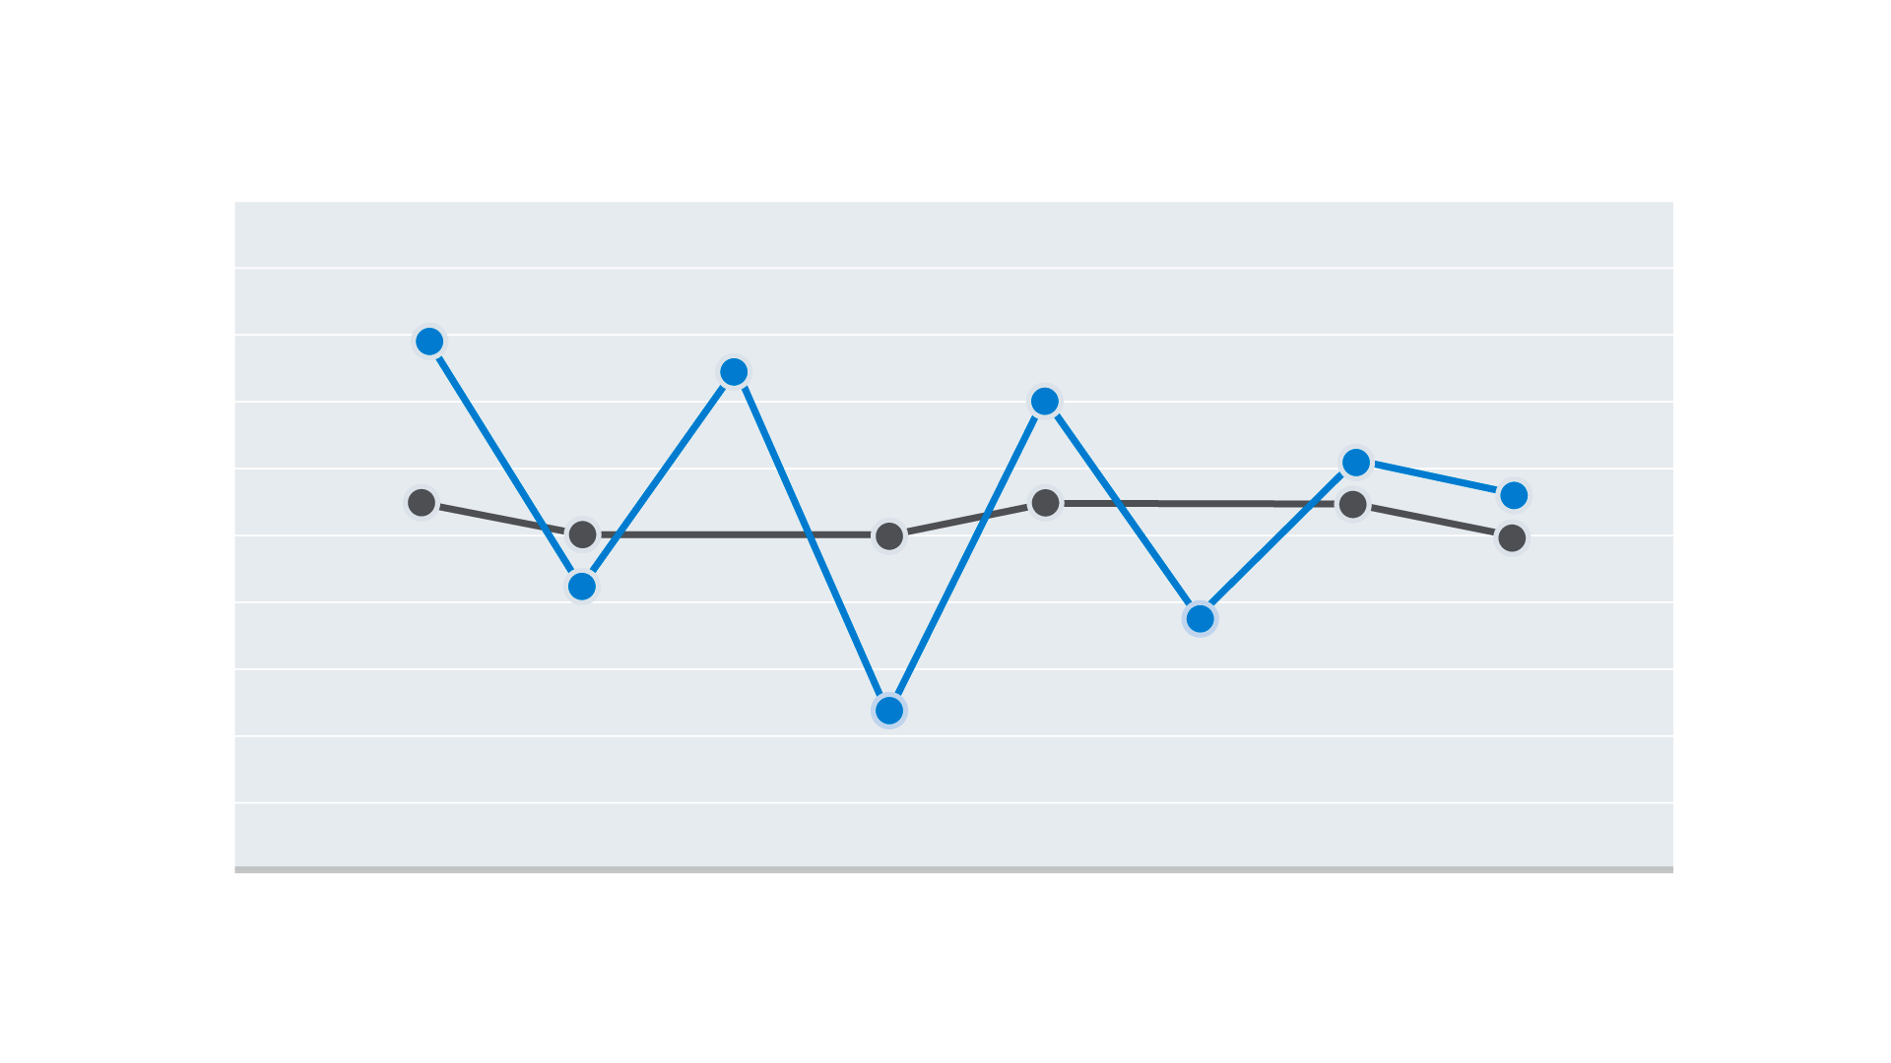

Figure 1 A black horizontal line showing neurotypical concentration with small fluctuations up and down. A blue line showing neurodivergent concentration with large spikes up and down.

No two profiles are the same – even for people with the same neurodivergence. The profile demonstrates the range of strengths and challenges experienced by a person who is neurodivergent and why they sometimes appear inconsistent in their work, social skills, focus, energy and so on compared to their peers. For example, many tasks involve different skills or processes. If a person has a stable profile, they may find some aspects slightly more difficult than others. For the neurodivergent person, they may find some aspects very easy and others very hard.

## Executive functioning

Some of the barriers people who are neurodivergent experience are related to executive function. It is often talked about in the context of neurodiversity and is an important concept.

Executive functions are the mental processes we need to carry out key skills. There are three main types of brain function that are required for good executive function:

* Working memory – the temporary holding of information for immediate use such as problem-solving, arithmetic, following directions.
* Self-regulation – the ability to control behaviours, actions, and emotions, such as following rules.
* Mental flexibility – being able to adapt appropriately and in a timely way to new situations, such as switching work tasks.

These can then be broken down into a few skills needed in life and work, including:

* Planning and organisation.
* Prioritisation.
* Motivation / starting and finishing tasks.
* Time management.
* Focusing.
* Flexibility.
* Short-term working memory.
* Impulse control / self-regulation.
* Emotion control.
* Communication.

All the above are usually interlinked. See the adjustments section of this Toolkit for advice on managing employees with barriers related to specific processes listed above.

# Terms associated with neurodivergence

This section looks at the less common terms associated with neurodivergence. Some can be present from birth and others develop later in life. Some may be temporary.

## Tourette’s

Tourette’s is neurological, it may cause a person to ‘tic’.

Tics are sudden, repetitive, involuntary movements or sounds which can be painful and tiring. For example, repetitive rapid blinking, twitching of the head or making tongue-clicking noises.

## Dysgraphia

Dysgraphia affects an individual’s ability to write. It rarely occurs on its own. It is often accompanied by other neurodivergences. It shares many characteristics with dyslexia and dyspraxia.

Motor co-ordination, spatial perception and language skills can sometimes be affected. This may result in illegible handwriting which is not within the structures of lines or margins, and slow writing. They may also have difficulty with grammar, sentence structure and organising thoughts on paper.

Unlike difficulty with writing caused by illness or injury later in life (known as ‘agraphia’), dysgraphia is present from birth.

## Acquired brain injury

This term covers any brain damage that occurs after birth. It can be direct trauma following an accident, disease, infection, or a lack of oxygen. The location of the damage will determine what challenges the individual experiences.

Brain injury can affect areas such as:

* Memory.
* Concentration.
* Communication.
* Information processing (such as auditory or visual information).
* Time management.
* Emotions (such as empathy and resilience).

An individual with an acquired brain injury may experience new strengths or weaknesses in single or multiple areas.

## Menopause and hormonal changes

Researchers are starting to look at the links between hormone fluctuations and neurocognition.

The effects of menopause can sometimes replicate common neurodivergences, such as changes around sensory sensitivity, memory, and communication.

Menopause can also cause changes in pre-existing neurodivergences. Some who are neurodivergent find that they experience their neurodivergence differently during menopause.

Many who are menopausal and perimenopausal may benefit from adjustments suggested for individuals who are neurodivergent due to the similarity of challenges.

**Always talk to the individual about the barriers they are facing and work with them, and relevant experts, to find solutions.**

# Co-occurring neurodivergences

People with one neurodivergence are more likely than not to have at least one other neurodivergence. This is known as ‘co-occurrence.’ This will impact how their neurodivergence affects them as individuals. It will also inform the adjustments that are needed to help them function in a world that isn’t always designed for them.

The 2017 [Westminster AchieveAbility Commission for Dyslexia and Neurodivergence research report](https://www.achieveability.org.uk/files/1518955206/wac-report_2017_interactive-2.pdf) showed most respondents had more than one neurodiversity label.

## The experience of multiple neurodivergences

Some characteristics can be specific to one neurodivergence, while others are common to many neurodivergences.

A person with co-occurring neurodivergences may not experience them as separate. However, they may find that it affects a wider range of processes. The degree of positive or negative impact will depend on many interlinked factors. For example, a working environment can significantly affect a person’s work rate, accuracy and physical and mental wellbeing.

Some co-occurring neurodivergences can appear to contradict each other and cancel out some symptoms. For example, a person can be over and under stimulated at the same time. However, rather than reducing the effects for the person, the effect can be multiplied.

As with all disabilities, remember that each person is an individual. Even with one neurodivergence, the experience is unique to the individual. The same is true for people with co-occurring neurodivergence.

## Neurodivergence and co-occurence

Above we said that having more than one neurodivergence is known as ‘co-occurrence.’

People who are neurodivergent may be more likely to experience other symptoms that are not directly related to neurodivergence.

Although there is no formal consensus, some psychologists believe that people experiencing poor mental health are also considered neurodivergent due to similar experiences in the brain functions. It is not as widely acknowledged as ADHD, Autism or Dyspraxia but could include:

* Anxiety.
* Depression.
* Addiction.
* Post-traumatic stress disorder (PTSD).
* Self-harm (including suicidal thoughts).
* Eating disorders.
* Anger.
* Low self-confidence and self-esteem.
* Burnout – due to difficulty pacing work and/or trying to meet the others’ expectations.

### Other co-occurring factors may be:

* Migraines.
* Frequent headaches.
* Fatigue.
* Stomach and bowel irritation such as irritable bowel syndrome.
* Hypermobility - such as Ehlers-Danlos Syndrome.
* Pain due to constant physical tension.
* Allergies.
* Skin irritation may be worse due to neurodiversity-related stress.