Annual Report 2023

Who we are
Australian Network on Disability is a national member-based, for-purpose organisation. We empower our network of member organisations to be disability confident by providing expertise, tools, knowledge, and resources to welcome and include employees and customers with disability into their organisation.

Our purpose
To build employer capability and be the employer voice to government, industry, and community to achieve the inclusion of people with disability.

Our values
- Open
- Flexible
- Ambitious
- Collaborative

Our vision
A disability-confident Australia

Contents
Message from our Chairman and CEO 1 - 2
Growing disability confidence 3 - 4
Great from the inside out 5 - 6
Building member confidence and capability 7 - 10
Making connections 11 - 20
Measuring progress 21 - 23
Strategic development, Partnerships and Projects 24 - 28
Financial Performance 29
Our Board of Directors 30 -31
Australian Network on Disability members 32 - 44

Accessibility
To reduce our impact on the environment, limited copies of our Annual Report have been printed. Accessible PDF and Word versions are available on our website at www.and.org.au. If you require an alternative format, please contact us at info@and.org.au.

Acknowledgement of country
We acknowledge the traditional owners of the lands on which we operate and pay our respect to Elders both past and present.

MESSAGE FROM OUR CHAIRMAN AND CEO
We are delighted to present the 2022-2023 Annual Report. It has been an extraordinary year of growth and achievement for the Australian Network on Disability.
This year, we welcomed 92 new members, taking us to a record number of 440 organisations who are committed to increasing the disability confidence of their workforce, and greater inclusion of people with disability within their workplaces. The growth we have seen in participation across all of our programs and services is clear indication that this commitment has not been taken lightly by our members.

Our Stepping Into Internship and PACE Mentoring programs continued to attract strong demand with 21% of our members hosting an intern, 313 internships completed and 361 PACE mentoring matches. We were thrilled that 100% of members reported that they felt confident in managing and supporting an employee with disability after taking part in our award-winning Stepping Into program.
As our network continues to grow, we have continued to encourage individual senior business leaders to advocate for inclusive employment practices. We are grateful to our 160 Disability Champions who are helping to lead the way across their organisations.
We were heartened to see a growing number of our members are measuring their progress towards disability inclusion by taking part in our Access and Inclusion Index.
We recorded a 51% increase in the number of organisations completing our
comprehensive self-assessment, a 25% jump in submissions for evaluation and benchmarking, and a 12% rise in our Quick 10 assessment.
In part, this has been made possible by our substantial investment in resources to enhance our influence, impact, and our specialised member services. This resulted in 12 newly created and specialised roles focused on delivering disability inclusion outcomes.
We also streamlined our IT systems to enable easier access to our E-learn modules, our Access and Inclusion Index, Disability Confident Recruiter training and the Quick 10 assessment.
In July 2022 we began work on our 2022- 2025 Strategic Plan to create a disability confident Australia and we are delighted to report that progress against this Plan is 50% complete.
In November 2022 we conducted a series of surveys with our member organisations, to

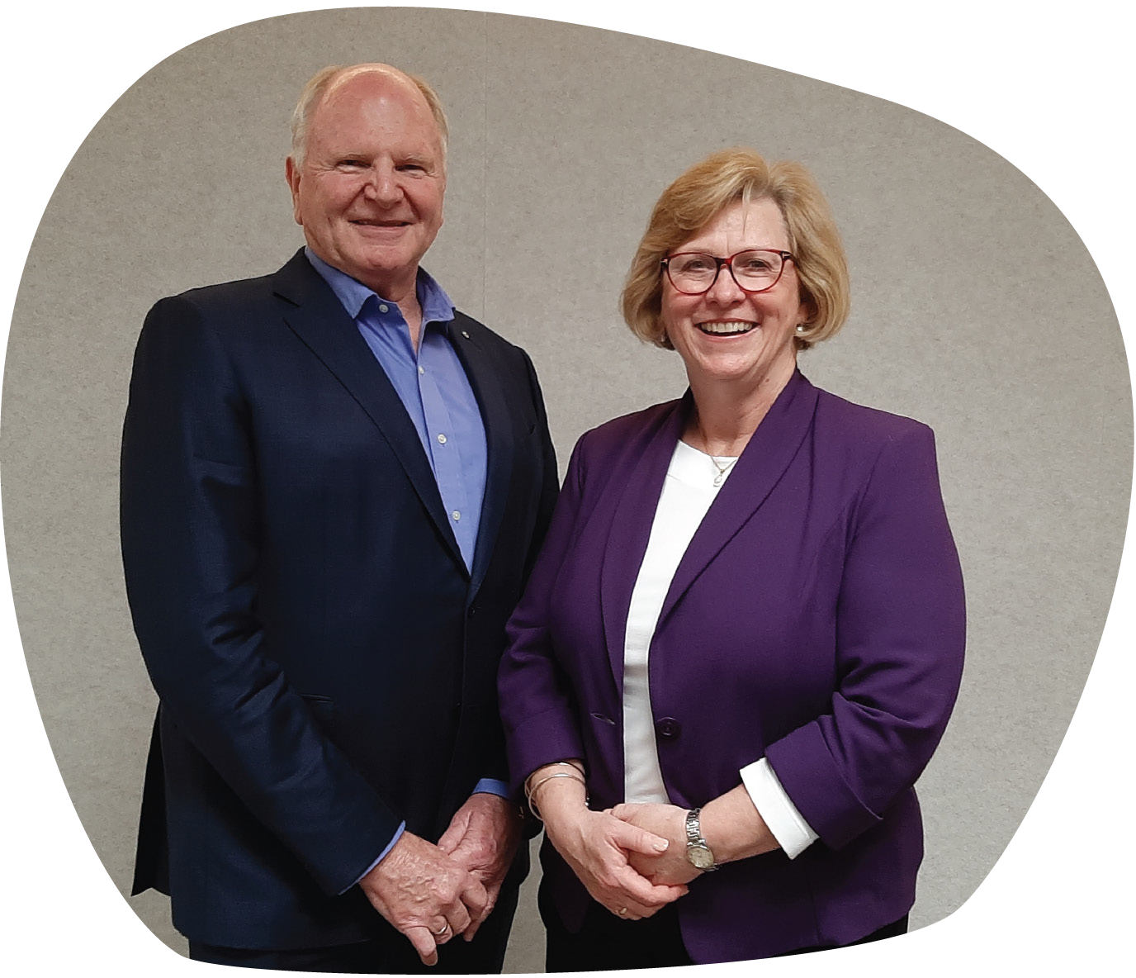Image of Chairman
Peter Wilson and CEO
Corene Strauss

capture much-needed data on the employment of people with disability in Australia. The surveys attracted more than 400 responses and we will continue to undertake vital research into workplace adjustments and employment attitudes and practices in the coming year.
A record 506 delegates attended our annual conference and more than 200 people attended our annual awards ceremony which recognised the achievements of individuals and organisations who are working towards greater disability inclusion. We were amazed by the determination and accomplishments of our incredible finalists and award winners.
We were extremely proud that the Australian Network on Disability’s unique culture was recognised in the 2023 AFR BOSS Best Places to Work awards, when we
Following an extensive period of research with members and stakeholders, we are excited to announce we are changing our name to Australian Disability Network Limited. Our new name will come into effect after the 2023 Annual General Meeting.
In conclusion, we would like to thank our team, Board, and members for their commitment, innovation, and hard work. Creating systemic change takes time and we have no doubt that our efforts to remove employment barriers will lead to a disability confident `Australia where people with disability can participate equitably as employees, customers, and stakeholders.

came 2nd in the Government, Education and Not-for-Profit category. The award illustrates the passion and outstanding commitment of our talented team.
Peter Wilson AM
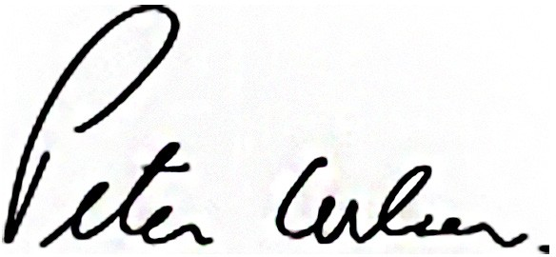
Chairman
Corene Strauss
CEO

GROWING DISABILITY CONFIDENCE
During the 2022-23 financial year, Australian Network on Disability significantly increased the influence and confidence of our rapidly expanding network. We invested in resources and enhanced our specialised member services. We:
- Increased our staff numbers from 30 to 45
- Increased our membership by 16% to 440 organisations
- Created a new Consultancy division and Strategic Development team to give our flagship programs and services greater focus
- Completed 50% of our 2022-25 Strategic Plan by June 30, 2023
- Streamlined our IT systems to enable easier access to our E-learn modules, our Access and Inclusion Index, Disability Confident Recruiter training and the Quick 10 Assessment
- Conducted a series of surveys with our member organisations to capture much-needed data on the employment of people with disability in Australia
440 Workplaces are part of our growing network
92 New members welcomed in 2022-23
2.2M Approximate combined employees representing 18% of Australia’s workforce

We connected our industry and provided opportunities to learn

506
Conference delegates in person and online
27%
Growth in our members having an Employee Resource Group (ERG)
661
Roundtable
Attendees
44
Dignified Access Reviews completed
227
Disability Confidence Training sessions delivered
319
Organisations checked their progress by using the Access and Inclusion Index Quick 10 Assessment

Our network grew its confidence through our programs

361
PACE mentoring
21%
Of our members hosted at least one intern
313
Stepping Into Internships completed

GREAT FROM THE INSIDE OUT
Australian Network on Disability experienced unprecedented growth in the last financial year. We increased our staff numbers by 50%, creating specialised roles to better serve our members and the disability community, we expanded our membership and we completed 50%
of our 2022-25 Strategic Plan
Image: Australian Network
on Disability team

Growing stronger
The rapid growth of our network and the commitment to achieving our vision of a disability-confident Australia prompted a substantial investment in our team.
We introduced:
15 new team-mates

12 new roles

2 new divisions:
Consultancy and
Strategic Development

42% of our employees live with a disability

Our culture
Australian Network on Disability’s leadership strongly believes the contribution, wellbeing and success of every employee is essential for the organisation to achieve its goals.
Every day Australian Network on Disability applies its COFA values – Collaborative, Open, Flexible, Ambitious – to every employee and every aspect of its workplace and culture.
Our relaunched and expanded Culture Club has five key pillars: Social Connection, Living our Values, Learning Opportunities, Pulse Surveys and Days of Significance.
We were proud to come second in the 2023 Australian Financial Review Best Places to Work Awards in the Government,
Education, and Not-for-Profit category

Image: Australian Network on Disability
Board Members (Absent - Susan Davies and Kevin Figueiredo)

BUILDING MEMBER CONFIDENCE AND CAPABILITY
Our consulting and learning programs are designed to achieve our vision of a disability confident Australia. We work with our members to develop tailored learning solutions and guidance suited to their individual needs.

Consulting with our members
Working closely with our members to implement inclusive workplace initiatives is one of the most important parts of our work at Australian Network on Disability.

It’s through Workplace Adjustment Policies, Recruitment Reviews, and other programs that we are able to work with our members to build a disability confident Australia.
In October 2022, we created a new
Consultancy Team to complement our
Member Experience Team, and further extend our ability to deliver these programs. This has allowed us to deliver record numbers of Access and Inclusion Index participants, Disability Confident Recruiter awardees, Dignified Access Reviews and Training sessions.
16 Member organisations developed Workplace Adjustment Policies
15 Organisations completed
Recruitment Reviews
19 Organisations developed Accessibility Action Plans

13 Member organisations completed the Access and Inclusion Plan Masterclass
44 Dignified Access Reviews
Many of our member organisations fine-tuned their hybrid work models as employees increasingly returned to the office part time.
This saw the number of organisations undertaking Dignified Access Reviews to ensure their workspaces were accessible and inclusive jump by 214% from 14 last year to 44 including Australian Parliament House.
Our Access & Inclusion Plan MasterClass supported 13 member organisations to successfully scope, develop and launch an Access & Inclusion Plan. The MasterClass provides attendees with the opportunity to learn from other organisations through informative workshops, guest speakers, sharing experiences and best practice and collaborative learning sessions.

Learning Solutions
227 Disability Confidence training sessions delivered
20 organisations purchased our E-learn modules, giving approximately
100,000
employees the opportunity to access the training.
Our facilitated training provides the knowledge, skills, and tools for individuals and organisations to be able to confidently welcome employees, customers, and other stakeholders with disability. In fact, since April 2023, we have recorded a 41% increase in the disability confidence of participants after training.
This year tailored training continued to be highly sought after with 227 disability confidence training sessions delivered.
While our E-learn modules continue to facilitate greater awareness and understanding of disability inclusion and accessibility, and lead to cultural change in many organisations.

Employee Resource Groups
Employee Resource Groups (ERGs), also known as Disability Employee Networks (DENs) can provide crucial and valuable support in building and maintaining accessible and inclusive workplace culture. These are voluntary, employee-led groups that amplify the voice of people with disability and create a collaborative space to learn directly from people with disability.
ERGs often lead organisations’ disability inclusion journeys.
We work with our members to establish or re-assess their ERGs. We engage ERG members, facilitate sessions on what an ERG is, establish action plans and help review the ERG’s current or future activities.
156 Members have an ERG
27% Growth of ERGs since last year

Learning opportunities
Our Head of Consultancy, Emma Henningsen won a scholarship through the Stanford Australia Foundation and attended an Executive Program for Non-Profit Leaders (EPNL) at Stanford Graduate School of Business in California.
Emma will use the knowledge she gained from the program to review Australian Network on Disability’s current growth and expansion phase and to support our team to complete the Stanford Business Impact Model for each of our key business areas.

“There were numerous moments during the course – both in the theory and in the conversations with other leaders – where I could see that, as an organisation, Australian Network on Disability is headed in the right direction.”
– Emma Henningsen

Image:
Australian Network on Disability team member Emma Henningsen with fellow participants of the Executive Program for Non-Profit Leaders 2023 and Study Tour.

MAKING CONNECTIONS
We connect the leading Australian organisations in our growing network in many ways so they can learn from one another and share experiences. From our social community of 40,984 followers to our roundtables, our mentoring and award-winning internship and scholarship programs to our Awards Night, our Annual National Conference and our end-of-year cocktail party to celebrate International Day of People with Disability.

Stepping Into Internship Program
21% Members that hosted at least one intern

313 Internships completed across the summer and winter cohorts from 850 applications

38%Interns that had their employment extended beyond the internship
The award-winning Stepping Into Internship Program gives university students and recent graduates with disability the opportunity to undertake a paid internship with one of our member organisations. The program breaks down outdated stereotypes and misconceptions about the capabilities of people with disability.
The program continues to break records. The 2022-23 summer program was our largest cohort with 189 internships completed.
Members consistently tell us that they find the Stepping Into Internship Program enriching and eye-opening. The program and the calibre of candidates often surpassed their expectations, resulting in many hiring more interns than planned.
Image: Stepping Into participant Daljinder
during his Physical Metrology internship with
National Measurement Institute (hosted by the Department of Industry, Science and Resources)

Members built disability confidence
92% Said they would participate again

100% Reported increased disability confidence and awareness

92% Felt the information and support from Australian Network on Disability met or exceeded expectations

94% Rated the intern’s work to have met or exceeded their expectations

Interns learnt valuable workforce skills
93% Reported feeling better prepared for the workforce

98% Would recommend the program to other students

38%Had their employment extended beyond the internship

91%Felt the support Australian Network on Disability provided met or exceeded expectations
The Alumni Connect network would not be possible without the support of our Founding Partners:
- Acciona
- Commonwealth Bank of Australia
- Deloitte
- IAG
- Life Without Barriers
- QBE

New Alumni Network
In May 2023 we launched Alumni Connect, Australia’s first alumni network for talented university students with disability. The network connects over 2,200 alumni who have taken part in the Stepping Into Internship Program over the past 18 years, with employers who want to broaden their employment pool.
The Alumni Connect network provides graduates with further opportunities to fast-track their careers by building relationships with employers, attending development events, networking, and gaining confidence in the workplace. The network also presents an exciting opportunity for our members who are dealing with a tight labour market and are looking for highly skilled employees across a broad range of industries.

PACE Mentoring Program
361 Mentoring matches Mentoring matches across the autumn and spring cohorts

65% Mentor organisations with return participants

PACE (Positive Action towards Career Engagement) is an internationally recognised, mentoring program that brings people together to learn, develop and progress their career skills.
Mentors increase their disability confidence and leadership skills, while students and jobseekers with disability gain vital workplace understanding, increase their confidence and expand their networks.
Mentors developed their leadership skills
93% Said they would participate in the program again

98% Growth in the confidence of mentors to manage and support an employee with disability

29% Felt they had learnt more about the potential barriers experienced by people with disability
“The two internships at Macquarie Bank and The Department of Treasury and Finance would not have been possible without the invaluable program that the Australian Network on Disability provides. It gives everyone a fair opportunity. I could not imagine being in the position I am in through the traditional methods of graduate employment.” – Santhush Gunawardene, Intern
Image (left to right):
Stepping Into Alumni Givens Boakye-Yiadom
and Santhush Gunawardene
“I had an excellent experience with the PACE program and am grateful for the opportunity to participate. It has also led to conversations with work colleagues who also have ADHD and their experiences. I am very fortunate that I was matched with an enthusiastic and friendly mentee who made my first experience as a PACE mentor such a good one.”
– Whee-Jong Lim, Mentor

Mentees also became more job ready

42%
Growth of confidence with job interviews for mentees
31%
Of mentees who applied for a job throughout the program were successful
92%
Said they’ll stay in touch with their mentor after the program

“I came into the PACE mentoring program with an open mind and I am so glad I signed up. As a consequence of meeting [my mentor] through this program I am more confident in bringing my full self to work (and life), taking a strengths-based approach to disability, and striving to be a leader that makes the world more inclusive like [my mentor] does.”
- Maddison Nicholls, Mentee

Leaders with disability on Australian boards
Our Directing Change programs are designed to support leaders with disability to develop their board governance careers, and increase the representation of people with disability on boards.
The Directing Change Scholarship Program saw 15 leaders with disability undertake either the Foundations of Directorship program or the Company Directors Course at the Australian Institute of Company Directors (AICD).
An important aspect of this program is the opportunity to be mentored by an Australian Board Director.
144 Applications for scholarship

15 Leaders with disability selected

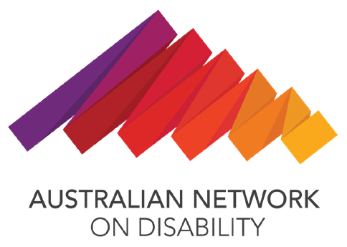
298 Director requests to mentor scholarship recipients
The Disability Leadership Program is a two-year partnership program with AICD and is funded by the Department of Social Services. In Year One, 100 scholarships were awarded to leaders with disability. Selected leaders also participated in Leader to Leader conversations that connected leaders with disability to board directors, through storytelling.
Australian Network on Disability has also supported AICD to build the disability confidence of their facilitation team, with learner adjustment implementation and dignified access premises reviews.
“I was honoured to hear the stories and experiences of people impacted by disability and look forward to sharing my learnings and building more equitable, accessible, inclusive and diverse workplaces.”
– Leader to Leader Director, 2023
We also piloted a new Directing Change Mentoring program with eight pairs of mentors and mentees to enable leaders with disability to better understand the world of governance and build their confidence, connections, and capabilities. Mentors developed disability confidence to make their boards more inclusive for people with disability.

Member Roundtables
As Australia’s peak body for the inclusion of people with disability in the workplace, our roundtables link our members across the nation to share best practice, discuss
insights and learnings, and amplify the lived experience of people with disability.
Thank you to the speakers of our Members Roundtables, and the insights, experiences and knowledge shared.
Our 2022-23 roundtables covered topics including invisible disabilities and neurodiversity in the workplace, inclusive procurement, increasing leadership opportunities for people with disability and more.
661 Attendees
over 4 Roundtables

Awards Night
Once again, our annual awards night was a heartfelt celebration of the passion, determination and the achievements of individuals and organisations who have worked hard and instigated changes to improve accessibility and inclusion of people with disability.
Almost 100 organisations and individuals entered the awards, and more than 200 people attended the awards ceremony at The Fullerton Hotel in Sydney on June 5.
Image:
Australia Post collecting their awards
Our expanded awards acknowledged:
- Access and Inclusion Index Top Performers
- Disability Inclusion Changemaker of the Year
- Disability Confident Recruiters
- Inclusive Initiative of the Year
- Disability Employee Network
of the Year
- Mentor of the Year
- Supervisor of the Year.

18

Annual National Conference
19
Our 2023 National Conference brought together a record 506 attendees to hear 24 local and international speakers. The hybrid event was held on June 6 at the Hilton Sydney. Topics included achieving
disability employment equity, neurodiversity in the workplace, insights from disability- inclusive organisations, accessible products, services, and design and exploring the complexities of disability experience.
The conference sparked lively discussions, ideas and networking between presenters and attendees.
19
“Thank you for a wonderful conference. I laughed, I cried - but above all, I’ve never felt more seen. Today has given me homework. I have a list of people I need to talk to. I have pages of notes, but I also have a revitalised approach towards a more inclusive future.”
– Dani Maidens, Department of Infrastructure, Transport, Regional Development

Champions Network

Senior leadership is critical to drive momentum and change in organisations. Disability Champions are the senior executives who encourage and support inclusive practices for people with disability in their workplaces.
These executives play a vital role in creating organisational change to welcome people with disability as employees, customers and stakeholders.
160 Disability Champions from
137 of our member organisations
36%Of our network has one or more Disability Champions
The individual influence of champions is amplified when they come together for our Champions Network Meetings. The Champions met six times in 2022-23 in Melbourne, Sydney, and Canberra.
The virtual and hybrid meetings covered topics including disability employment targets, overcoming discrimination and harassment, and reasonable adjustments.

Image:
Award night attendees with Australian
20
Network on Disability CEO, Corene Strauss 20

MEASURING PROGRESS
Regular measurement and reporting are known to strengthen focus, inform decision-making to improve results and drive action. Our Access and Inclusion Index and Disability Confident Recruiter Program achieve these results.

Access and Inclusion Index
Members of Australian Network on Disability use our world-class Access and Inclusion Index to measure their progress in accessibility and inclusion, spark conversations about disability inclusion across the entire business, benchmark their scores and identify areas for improvement.
The areas the Index measures include:
- Commitment
- Premises
- Workplace Adjustments
- Communication and Marketing
- Products and Services
- Information Communication Technology
- Recruitment and Selection
- Career Development
- Suppliers and Partners
- Innovation
319 Organisations completed the Quick 10 assessment

65% Organisations completed the self-assessment

Highest Performing Key Area: Commitment

Lowest Performing Key Area:
Suppliers and Partners
.
Learnings for our evaluation and benchmarking data
Our 2022-23 Access and Inclusion Index participants helped provide key data on organisational maturity, progress and impact. One of our biggest learnings was that organisations previously participating in the Index saw stronger results in their next involvement.
33 Organisations submitted for evaluation

80% Of Top 10 Performers were repeat participants

18% Is the average score of first time participants

48% Is the average score of returning participants

Congratulations to our 2022-23 Index Top Performers

4. Australian National University

5. Henes Brands Australasia

6. • AGL (first time)
• Attorney-General’s Department

7. • Australian Broadcasting Corporation)
• Civil Aviation Safety Authority
• Department of Industry, Science & Resources
8. Bendigo & Adelaide Bank

9. The University of Queensland (first time)

10. IAG

Disability Confident Recruiter
Disability Confident Recruiter (DCR) Program equips organisations to identify and remove unintended barriers to candidates with disability during the recruitment and selection process. As
a result of achieving Disability
Confident Recruiter status, organisations provide a fair and equitable recruitment experience, and are more successful in attracting and retaining skilled and talented candidates with disability.
This financial year 11 organisations renewed their DCR status and 9 organisations completed the DCR program for the first time.

STRATEGIC DEVELOPMENT, PARTNERSHIPS AND PROJECTS
Our partnerships, with our national and international allies, strengthen our network and support us as we strive to achieve equity and inclusion for people with disability.

Disability Observership Pilot
The Disability Observership Pilot provides training and practical experience in
Not-for-Profit board leadership for passionate, emerging community leaders. This pilot initiative supports The Observership Program to access the entire talent pool and build a pipeline for leaders with disability into governance roles on Australian boards.
We have supported the Observership Program and the Not-for-Profit Boards involved in the program to build their disability confidence and ensure that the program is accessible and inclusive for all Observers.
The 2023 program has matched 13 Observers with disability with Not-for-Profit Boards, including Ronny Andrade Parra who is currently observing the Australian Network on Disability Board.

Employing 100
Employing 100 is a grant initiative funded by the Department of Social Services through their Building Employer Confidence grants program, with the aim
to place 100 job seekers with disability into roles in the Health Care and Social Assistance, and Food and Accommodation industries.
As part of the grant delivery, we initiated a Community of Practice for grant recipient organisations to foster collaboration and knowledge sharing.

Accessible Procurement Taskforce
Our Accessible Procurement Taskforce, under the leadership of Matt Hawkins (University of Melbourne), have been developing a suite of tools that will make it easy for organisations to select accessible technology. This will support the Accessible ICT Tender Tool available on our website.

Image (left to right): Observer Ella Broadbent with Amy Griffiths, Australian Progress

Operating model review
We have undergone a significant review of our organisational structure since the Strategic Plan launched in July 2022. This initiative has given us the opportunity to assess our team functions and introduce vital new teams and positions to ensure the successful delivery of our services, programs, and projects.
We have achieved:
- A functional analysis that identifies career progression and succession planning opportunities
- A detailed review of all position descriptions
- Successful creation and onboarding of 12 new positions
- Greater role specialisation with subject matter experts

Influencing change
Our purpose is to build disability confidence, employer capacity and be the employers’ voice to government, industry, and community to achieve the inclusion of people with disability.
Our leadership team regularly speak to the media, at conferences, and member and industry events to raise awareness of disability inclusion.
This year our CEO Corene Strauss and our leadership team spoke at events including the Jobs Australia Summit, the Diversity and Inclusion Forum, the National Disability Summit, the Not-for-Profit People Summit, and the Disability Employment Australia Conference.
We also regularly submit papers to influence and shape government policy. This year, our submissions included:
- input into The Review of Public Sector Board Appointments Processes in June2023
- a response to the Fair Work Act Consultation Paper in May 2023
- a response to the Employment White Paper in November 2022

Member Charter
We launched a new Member Charter that outlines how we promise to work with our members and what they can expect from us.
It has been designed to be short and sweet so it can be easily used. It is a simple guide for members and Australian Network on Disability staff to understand the commitment and realistic expectations within membership.

Decision-making tools
To help us develop new products, programs, projects, or partnerships, that align to our strategy, vision, and purpose, we implemented a new strategic alignment framework. This will allow us to develop products and services that
meet our members’ needs. This method will also contribute to our sustainability by allowing us to analyse activities, resources, values, risks, and revenue streams involved in the development and maintenance of all new programs, services and projects.

Redesigned education model
To streamline our training processes, support resourcing, and bring Australian organisations together to learn from and with each other, we developed and rolled out our Multi-Organisation Training Calendar.

Research and data collection

Australian Network on Disability Member Surveys
As the peak body for disability inclusion in the workplace Australian Network on Disability is committed to addressing the critical lack of research and data about people with disability in Australia.
We welcomed a Research Lead to our team, Dr Catherine Maitland, PHD.
We conducted a series of short surveys into our 400 member organisations, to help us capture much-needed data on the employment of people with disability in Australia.

Business Council of Australia/Australian Network on Disability report
In late 2022, the Business Council of Australia (BCA) in partnership with Australian Network on Disability, released a scoping survey to its members
to generate information on existing strategies and activities by members covering recruitment, retention, and advancement of people with disability.
The scoping survey provided valuable insight into:
- Foundational practices members are taking, including commitments and accountability
- Emerging trends, including practices to support workplace culture and inclusion
- Imperatives for success where the focus has shifted from attraction and recruitment to a focus on engagement and development.
This report presents the key findings across these domains and best practice case studies to assist members to drive further gains in employment outcomes.

FINANCIAL PERFORMANCE
We are pleased to report a surplus of $201,614 for the financial year. There has been a significant expansion in the activities and these are reflected by the increase in revenue to over $6m, 31% higher than the previous year.
Employing the principles of sustainability and increasing the offerings and services to members has been the focus financially this year. Australian Network on Disability membership base increased by 92 which has allowed the expansion of activities to support the members. Our product offerings which include the programs and learning have been well received and supported by members.
We were awarded a number of grants and have been delivering these to their guidelines.
Our expenses and salary costs, which enable the delivery of the services, has grown in line with the increased revenue.
We continue to being committed to utilising fit for purpose digital systems that allow us to gain efficiencies and deliver our services to members in a contemporary manner. We have developed an inhouse product that allows us to capture submissions for the Access and Inclusion Index and Disability Confident Recruiter processes. We upgraded our security and will continue to review our system security to ensure they are secure. We remain in a strong financial position and will continue to focus on the delivery of products and services for the future.

Income
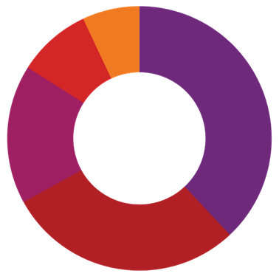
$6,253,785

Membership 38%
Programs 29%
Training and consultancy 17%
Service delivery 9%
Events 7%

Expenses
$6,052,171
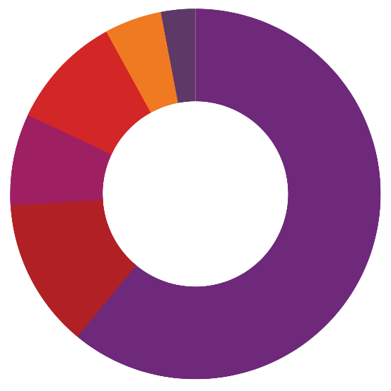
Employee benefit costs 61%
Administrative costs 13%
Information technology 8%
Service delivery costs 10%
Depreciation 5%
Marketing 3%

MANAGING RISK
Australian Network on Disability operates a Risk Management Framework which defines our structured approach to the management of risk and how this approach supports the achievement of our strategic aspirations, vision, purpose and values. It also safeguards our resources,
people, finance, property, knowledge and reputation. It is everyone’s responsibility within Australian Network on Disability to manage risk. The accountability for managing any specific risk sits with the person most appropriate to manage that risk. For the Framework to be effective, it has been integrated into our strategic and business planning cycles.

OUR BOARD OF DIRECTORS
Our sincere thanks to our Directors for their leadership, governance and
strategic guidance through another year of strong performance.

Peter Wilson AM
FCPALife, FCPHRLife, FAICD,
Chairman
Finance, Audit and Risk Management Committee, Nominations and Remuneration Committee
David Davies
Secretary
(Retired effective 30 November 2022)
Ainsley Barahona Santos
GAICD
Belinda Curtis
Finance, Audit and Risk Management Committee, Nominations and Remuneration Committee
Susan Davies
GAICD
Nominations and Remuneration
Committee
Maryanne Diamond AO
GAICD
(Retired effective 30 November 2022)

Kate Eastoe
GAICD
Finance, Audit and Risk
Management Committee
Kevin Figueiredo
GAICD
Finance, Audit and Risk
Management Committee
Rosie McArdle
Nominations and
Remuneration Committee
Donna Purcell
GAICD
Nominations and
Remuneration Committee
Rania Saab
Nominations and
Remuneration Committee
Ainslee Scott
MAICD, FCPA
Finance, Audit and Risk Management Committee, Nominations and Remuneration Committee
Alyson Tong
GAICD, FCPA
Finance, Audit and Risk
Management Committee

Image: Attendees at our Annual Conference during question time

AUSTRALIAN NETWORK ON DISABILITY MEMBERS
Membership and program participation as at 30 June 2023

PLATINUM MEMBERS
Australian National University – Access and Inclusion Index Top Performer
Compass Group
IBM – PACE participant
McDonald’s
Sparke Helmore Lawyers – PACE participant
The Sydney Children’s Hospitals Network – Stepping Into participant
Westpac – Disability Confident Recruiter, Disability Inclusion Changemaker of the Year winner, Roundtable speaker

GOLD MEMBERS
Accenture – PACE participant
AGL – Access and Inclusion Index Top Performer, PACE participant, Stepping Into participant
Alstom – Stepping Into
participant
ANZ – Conference speaker, Disability Employee Network of the Year finalist, Disability Inclusion Changemaker of the Year finalist, PACE participant, Roundtable speaker
APM
Arup – PACE participant, Roundtable speaker, Stepping Into participant
Attorney-General’s Department, Commonwealth – Access and Inclusion Index Top Performer, Conference Major Sponsor and speaker, Disability Champions Meeting host, Stepping Into participant, Supervisor of the Year winner
Australia Post – Access and Inclusion Index Top Performer, Disability Confident Recruiter, Disability Employee Network of the Year finalist, Inclusive Initiative of the Year finalist, Stepping Into participant
Australian Health Practitioner Regulation Agency
Australian Institute of Company Directors
Australian Institute of Health and Welfare – Stepping Into participant
Australian Museum – Conference speaker, Inclusive Initiative of the Year finalist, Stepping Into participant
Australian Taxation Office
Australian Trade and Investment Commission – Stepping Into participant
Bendigo and Adelaide Bank – Access and Inclusion Index Top Performer, PACE participant
BHP – Stepping Into participant BNP Paribas – PACE participant Brotherhood of St Laurence Bupa Australia – Stepping Into participant
Coles Group – Conference Gold Sponsor, Disability Confident Recruiter, Disability Employee Network of the Year finalist, PACE participant, Stepping Into participant
Commonwealth Bank of Australia – Stepping Into participant
Cummins South Pacific
Curtin University Dabserv
Department of Agriculture, Fisheries and Forestry
Department of Climate Change, Energy, the Environment and Water
Department of Defence
Department of Education, Commonwealth – Stepping Into participant
Department of Employment and Workplace Relationships
Department of Health and Aged Care, Commonwealth
Department of Industry, Science and Resources – Access and Inclusion Index Top Performer, Stepping Into participant
Department of Infrastructure, Transport, Regional Development, Communications and the Arts – PACE participant, Stepping Into participant
Department of Justice Tasmania
Department of Parliamentary Services
Department of Social Services
Department of the Prime Minister and Cabinet
Edith Cowan University
George Weston Foods – PACE participant, Stepping Into participant
Griffith University
Hanes Australasia – Access and Inclusion Index Top Performer, PACE participant, Roundtable speaker
Icare
Infosys – Disability Confident Recruiter, PACE participant
KPMG – Disability Champions Meeting host, Disability Employee Network of the Year finalist, PACE participant
Laing O’Rourke – PACE
participant
Legal Aid Commission of NSW
Lendlease
Life Without Barriers – Conference speaker, Disability Champions Meeting speaker, Disability Confident Recruiter
L’Oreal
Major Transport Infrastructure Authority – Stepping Into participant
Medibank – Access and Inclusion Index Top Performer, Conference Silver Sponsor, PACE participant
Metro Trains Melbourne Microsoft
Millennium Services Group MinterEllison
Monash University –
Conference speaker
n i b
National Australia Bank – Access and Inclusion Index Top Performer, Disability Champions Meeting host,
PACE participant, Stepping Into participant
National Disability Insurance Agency – Stepping Into participant
National Indigenous Australians Agency
NBN Co – PACE participant
Nestle – Stepping Into participant
North East Link South Alliance
North Sydney Council
Northern Territory Government
NSW Department of Communities and Justice – Conference speaker, Disability Confident Recruiter, Stepping Into participant
NSW Department of Planning and Environment
NSW Office of the Director of Public Prosecutions – Stepping Into participant
Pacific National
Parliament of Victoria – PACE participant
Qantas Airways QLD Department of
Communities, Housing and
Digital Economy – Stepping Into participant, Supervisor of the Year finalist
QLD Department of Transport and Main Roads – Disability Employee Network of the Year finalist, Inclusive Initiative of the Year finalist
RACQ
Scentre Group Scope (Australia) Settlement Services
International – Stepping Into participant
Sonder Care
St Vincent’s Hospital Melbourne
Suburban Rail Loop Authority Suncorp Group
Tasmanian Government
Telstra – Conference Silver Sponsor, Disability Confident Recruiter
Toyota
Transport Accident Commission
Transport for NSW – Conference speaker, Stepping Into participant
Transurban
Treasury Wine Estates – Disability Inclusion Changemaker of the Year finalist, PACE participant
UnitingCare Queensland
University of Sydney – PACE participant, Stepping Into participant
VIC Department of Energy, Environment and Climate Action – Stepping Into participant
VIC Department of Transport – Disability Inclusion Changemaker of the Year finalist
Victoria University
Victorian Public Sector Commission – Conference speaker, Disability Champions Meeting speaker
Virgin Australia Woodside Energy
Woolworths Group – Stepping Into participant
Worksafe Victoria
Zoos Victoria – Disability Confident Recruiter, Stepping Into participant

SILVER MEMBERS
Ability Options
Access Care Network Australia
ACCIONA – Stepping Into Participant
Achieve Australia
ACT Chief Minister, Treasury and Economic Development Directorate
ACT Justice and Community Safety Directorate
Alfred Health – Inclusive Initiative of the Year finalist
Allianz
Ambulance Victoria American Express
Anglo American Steelmaking Coal
Arriba Group Asahi Holdings Ashurst
Aurecon – Conference speaker
Ausgrid
Australian Broadcasting Corporation – Access and Inclusion Index Top Performer, Disability Employee Network of the Year winner, Inclusive Initiative of the Year winner, Stepping Into participant
Australian Criminal Intelligence Commission
Australian Energy Market Operator
Australian Federal Police – PACE participant
Australian Financial Complaints Authority
Australian Prudential Regulation Authority – Disability Champions Meeting host, Disability Employee Network of the Year finalist
Australian Public Service Commission – Disability Champions Meeting speaker, Mentor of the Year winner, PACE participant
Australian Securities and Investments Commission – Access and Inclusion Index Top Performer, Mentor of the Year finalist, PACE participant, Stepping Into participant
Australian Security Intelligence Organisation
Avanade
Brisbane City Council
Bunnings Group
Bureau of Meteorology – Stepping Into participant
Byron Shire Council CBRE
Cbus Super
Cenitex – PACE participant Charles Darwin University Cisco Systems Australia City of Bayswater WA
City of Canada Bay Council
City of Greater Dandenong – Stepping Into participant
City of Greater Geelong – Stepping Into participant
City of Parramatta City of Whittlesea
Civil Aviation Safety Authority – Access and Inclusion Index Top Performer
Clayton Utz – Stepping Into participant
Clean Energy Regulator Comcar

Commonwealth Ombudsman Country Fire Authority Court Services Victoria
CSL Behring Cumberland Council
Cushman & Wakefield – PACE participant
David Jones and Country Road Group
Defence Housing Australia Deloitte Australia
Department of Finance, Commonwealth – Stepping Into participant
Department of Foreign Affairs and Trade
Department of Veterans’ Affairs
Ernst & Young – Stepping Into participant
Essential Energy Fire Rescue Victoria
Ford Motor Company Frucor Suntory Fujitsu
Geoscience – Mentor of the Year finalist, PACE participant
Gilbert + Tobin GOTAFE
Government Employees Superannuation Board
GrainCorp
Grant Thornton Australia Hall & Wilcox
HCF – PACE participant
HSBC Bank
Hunter Water Corporation – Stepping Into participant
IAG – Access and Inclusion Index Top Performer, Disability Champions Meeting host, Stepping Into participant
IKEA
Insignia Financial
Clean Energy Regulator Comcar
IntoWork Australia
IP Australia – PACE participant
Jacobs Group – PACE participant, Stepping Into participant
Kmart
La Trobe University
Land Services WA Operating Trust – Stepping Into participant
Landcom – PACE participant
Latrobe City Council – Roundtable speaker
Leap in!
Legal Aid Commission of Western Australia
Macquarie Group – Stepping Into participant
Macquarie University Manpower Group
Mars Incorporated ANZ – PACE participant
MAX Solutions
McMillan Shakespeare Group – PACE participant
Melbourne Water
National Archives of Australia
NDIS Quality and Safeguards Commission – Stepping Into participant
Nine Entertainment Northcott
Norton Rose Fulbright Australia
NRMA

NSW Crown Solicitor’s Office – Stepping Into participant
NSW Department of Education – Stepping Into participant
NSW Department of Enterprise, Investment and Trade
NSW Department of Premier and Cabinet – Stepping Into participant
NSW Department of Regional – Stepping Into participant
NSW Police Force
Optus – PACE participant, Roundtable speaker
Origin Energy
Publicis Communications QAL Technologies
QBE Insurance Group – PACE participant, Stepping Into participant
QIC
QLD Department of Education
Queensland Health
Queensland Public Service Commission – Stepping Into participant
Queensland Treasury Corporation
Rabobank – PACE participant
Relationships Australia
Reserve Bank of Australia – Stepping Into participant
RMIT – Disability Confident Recruiter, PACE participant, Roundtable speaker, Stepping Into participant
Russell Kennedy Lawyers
Services Australia – Disability champions Meeting host, Inclusive Initiative of the Year finalist, Roundtable speaker
Special Broadcasting Service Stantec Australia
State Trustees
Stockland Corporation – Stepping Into participant
Swinburne University of Technology
Tabcorp TAL Life
Teachers Health Fund
Tetra Tech International Development
Thales
The Hollard Insurance Group – Disability Confident Recruiter
The Perth Mint
The Salvation Army
The Treasury, Commonwealth The University of Queensland – Access and Inclusion Index Top Performer, Disability Inclusion Changemaker of the Year finalist
TPG Telecom
Trustee for Enel Green Power Australia Trust
University of Canberra University of Melbourne
University of Melbourne Student Union
University of New South Wales V/Line Corporation
VIC Department of Families, Fairness and Housing – PACE participant, Stepping Into participant

VIC Department of Jobs, Skills, Industry and Regions – PACE participant, Roundtable speaker, Stepping Into participant
VIC Department of Justice and Community Safety – Stepping Into participant
VIC Department of Treasury and Finance – PACE participant, Stepping Into participant
Victoria Legal Aid
Victoria Police – Stepping Into Participant/
Victorian Electoral Commission
Victorian Government Solicitor’s Office
WA Department of Communities
Water NSW
Western Power
Western Sydney Local Health District
Yarra Trams
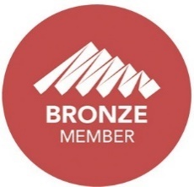

BRONZE MEMBERS
AECOM – Stepping Into participant
Ai-Media – Conference Sponsor and speaker
Allen & Overy Australia Amex Global Business Travel APSCo Australia
Asuria – Awards Night Sponsor
Audit Office of NSW
AUSTRAC – Stepping Into participant
Australian Competition and Consumer Commission
Australian Film, Television and Radio School
Australian Financial Security Authority – PACE participant
Australian Human Resources Institute
Australian Human Rights Commission
Australian Red Cross
Australian Research Council
Australian Retirement Trust
Australian Securities Exchange
Australian Super
Australian Strategic Property Advisers
Avant Insurance
Aware Super – PACE participant
Baker McKenzie – Stepping Into participant
Bartier Perry Lawyers
Beaumont People
Berry Street Victoria
Bloomberg
Built
Burnet Institute
Capgemini
CBM Australia

Centre for Inclusive Design Charter Hall
City of Newcastle City of Port Phillip
City of Sydney Council – Disability Confident Recruiter
CoAct
Colin Biggers & Paisley
Commonwealth Scientific Industrial Research Organisation
Convo Australia
Corrs Chambers Westgarth – Stepping Into participant
Deaf Connect – Conference
Sponsor and speaker
Deakin University Dentons Australia – PACE
participant
Department of Home Affairs
Department of Seniors, Disability Services and Aboriginal and Torres Strait Islander Partnerships
Department of the House of Representatives
Development Victoria
DFP Recruitment – Disability Confident Recruiter
Digital Transformation Agency
– Stepping Into participant Diversity Council Australia
DLA Piper
DXC Technology EACH
Endeavour Foundation
eSafety Commissioner – Stepping Into participant
Eurobodalla Shire Council
Fair Work Ombudsman – Stepping Into participant
Food Standards Australia New Zealand
Future Super Services Gateway Health
Goldman Sachs Australia Services
Good Sammy Enterprises
Guide Dogs NSW/ACT
Hawthorn Football Club
Hays
Health and Disability Services Complaints Office
HealthShare NSW
HireUp
HOBAN Recruitment
Horizon One
Hospitality Disability Network
Hudson Global Resources
Intopia
ISS Facility Services – Stepping Into participant
IVE Group

Jemena
JFA Purple Orange
John Holland
Ku-ring-gai Neighbourhood Centre
Kyndryl – PACE participant
Maddocks
Main Roads Western Australia Marsh McLennan
Matchworks
Maxima Training Group McCullough Robertson
MedHealth – Stepping Into participant, Supervisor of the Year finalist
MEGT – PACE participant Melbourne Cricket Club Menzies International Mercy Health
Meritos Group Michael Page MidCoast Council
Ministry for Primary Industries NZ
Mission Australia – Disability Confident Recruiter
Monash Health
Moreton Bay Regional Council
MTAA Superannuation Fund (Spirit Super)
Murdoch Children’s Research Institute
National Food Institute
National Health and Medical Research Council
National Library of Australia National Museum of Australia Neami National
NEC
New Plumbing Solutions
Northern Sydney Local Health District – Stepping Into participant
Nous Group
NSW Department of Customer Service – Disability Confident Recruiter, Stepping Into participant
NSW Health Pathology
NSW Ombudsman – Stepping Into participant
NSW Public Service Commission – Disability Confident Recruiter
NSW Reconstruction Authority
– Stepping Into participant
NSW State Emergency Service
NSW Treasury – Disability Confident Recruiter, Stepping Into participant, Supervisor of the Year finalist
Office of National Intelligence Office of Parliamentary
Counsel
Office of the Children’s
Guardian
Officeworks

Parks Victoria
Paxus
Penrith City Council
People for Purpose
People with Disability Australia
PEXA
Pfizer Australia – PACE participant, Stepping Into participant
Preston Rowe Paterson Sydney
PricewaterhouseCoopers
Productivity Commission
QLD Department of Premier and Cabinet
QLD Department of Resources
Queensland Treasury – Stepping Into participant
Randstad
ReadyTech
Restless Dance Theatre
Roche Australia
Safe Work Australia
Sanofi-Aventis – Stepping Into participant
Shell Australia
Shellharbour City Council
Société Générale Australia
Sodexo Australia
South East Water
State Insurance Regulatory Authority
State Library of NSW
Super Retail Group
Symal Infrastructure
Systra ANZ
Telecommunications Industry Ombudsman
The Adecco Group
The Art Gallery of NSW
The Boston Consulting Group
The Palladium Group
The Royal Women’s Hospital
TheirCare
Thomson Geer – Stepping Into Participant
Transdev Australasia
Unilever – Conference speaker
Uniting
University of Technology, Sydney
University of Western Australia
VIC Department of Education – Stepping Into participant
VIC Department of Health
Vicinity Centres
Victorian Managed Insurance Authority
Vision Australia
WA Department of Finance
WA Department of Training and Workforce Development
Walter & Eliza Hall Institute of Medical Research
Waverley Council WDEA Works Windermere
Women with Disabilities Victoria
WPC Group Xero
Yarra Valley Water
Yooralla
Youth Affairs Council of Victoria

Connect with us
Phone: 1300 363 645
Website: www.and.org.au Email: info@and.org.au Facebook: ANDisability Twitter: ANDisability
LinkedIn: www.linkedin.com/company/ANDisability Instagram: @andisability
© Copyright Australian Network on Disability 2023. ACN 605 683 369
Disclaimer: Unless otherwise stated, the information in this report has been compiled as at 30 June 2023. While every effort has been made to ensure the report is accurate, the Australian Network on Disability makes no warranty about its accuracy or completeness. To the extent permitted by law, the Australian Network on Disability, its directors, officers, employees and agents exclude all liability (whether in negligence or otherwise) for: Any error or inaccuracy in, or omission from, the report; and any loss or damage suffered by any person, directly or indirectly, through use of the report, including reliance on the information contained in the report and any membership decisions made on the basis of its content.

